REPORT ON A WORKING VISIT TO THE AHANTA WEST MUNICIPALITY BY THE WESTERN REGIONAL MINISTER ON THURSDAY, 22nd SEPTEMBER 2022

1.0 INTRODUCTION
The tour commenced at 10:00am with Courtesy Calls to Upper and Lower Dixcove Traditional Councils. From there, the Minister and his entourage inspected the ongoing Landing Beach and Sea Defense Projects at Dixcove. Then he met with the Ahanta Traditional Council, after that, he commissioned a Theatre at Agona Nkwanta Health Centre. The Minister and his team subsequently inspected works on the Agenda 111 Regional Hospital/Trauma Centre (Apemenim) and the Agenda 111 District Hospital at Bokoro to round up the working visit.

1.1 In Attendance
Hon. Dr Kwabena Okyere Darko-Mensah (Regional Minister), Hon. John Agyare (MCE for Ahanta West), Mr Daniel Kanyage (Ahanta West Municipal Coordinating Director), Mr Eric Agbo (Deputy Director Ahanta West Municipal Assembly), 3 staff of the Assembly. Regional Coordinating Director (Fredrick Agyeman), Justice Acquah (Aide to Regional Minister), Ebenezer Hadzide (Senior Planner WRCC), Akora Nfodzo Gabriel (Economic and Planning Officer WRCC), Daniel Ofosu Adjei (Regional Budget Office), DCOP Akoto Osei (Dep. Regional Police Commander), Capt. Hansen Obu rtd. (Regi Okpeti ( Ag. Regional GIS Commander), Assit. Commissioner Gloria M. Farmer (Sector Commander GRA/ Customs Division), Issah Fuseini (Npp Regional Communications Director), Hon. Samuel Jonfiah Fmr. MP)

Chiefs In Attendance:
Upper Dixcove
Nana Nda Esi III (Paramount Queen mother), Nana Kotakyi III (Tufuhene), Nana Diako Krah II (Apagyahene), Nana Kwesi Tanoh I (Mankrado), Nana Asuah Nkestiah II (Mamasenhene), Nana Ekow Gyisah (Ahohohene), Nana Essel, Obaahema Amakye Nda II, Obaahema Akasa Bolo III, Obaahema Ninsin III, Obaahemaa Esi Donko. Obaahemaa Dikyi Amanfo II, Obaahema Edibiasiabe, Obaahemaa Akua Atta, Obahemaa Nketsiaba, Obaahemaa Anuawa I, Obaahemaa Ekuaama, Obaahemaa Joviah I, Nana Ntwea Abrewa.

2.0 The Regional Minister’s Briefing
The Regional Minister stated the need to visit localities in the region to inspect ongoing projects. He said that, Dixcove was one of the towns His Excellency Nana Addo Danquah was very passionate about thus, his initiative to construct a Landing Beach at Dixcove.
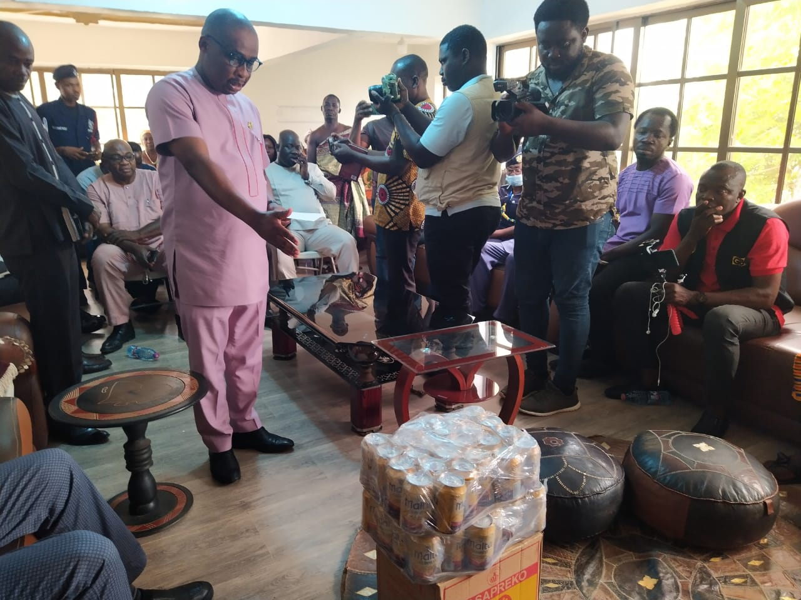
Figure 1: A courtesy call on Upper Dixcove Traditional Council with Hon. MCE presenting drinks to the council.
2.1 Commencement of new Projects
The Minister, indicated that some roads in the Municipality had been awarded on contract notably: the Dixcove - Agona road and Apowa – Agona road. He stated that, Covid 19 and the Russian Ukraine War had caused financial constraits to the Government resulting in the slow work pace on some projects. He, however, assured Nananom that, stalled projects in the Municipality would continue since the IMF and the Government were in talks for a facility to be released for the completion of such projects. He also appealed to Nananom to monitor ongoing projects periodically to keep contractors on their toes for timely completion of roads and other projects.

2.2 Rehabilitation of the Dixcove Hospital Morgue
The Minister mentioned that, Seventy-Five Thousand Ghana Cedis (75,000GHS) had been donated by the MP of the area Hon, Kojo Kum for the rehabilitation of the Dixcove Hospital Morgue.

3.0 Concerns Raised by Chiefs
3.1 Chieftaincy Disputes
All the three Traditional Councils appealed to the Regional Minister to intervene in the Chieftancy related issues in the area in order to promote peace and development. The Minister indicated that consultations and investigations were ongoing thus, the Regional Security Council would present a report on its findings for necessary action to be taken since his priority was to protect lives and property. He, however, appealed to the Chiefs to put aside their differences and try to resolve issues internally in order to attract investors to bring jobs for the youth of Ahanta.

3.2 Distribution of Pre-mix Fuel
Nana Asuah Nketsiah appealed to the Minister to help resolve issues related to the allocation and distribution of pre-mix fuel to fisher folks in the area. He said that, due to its periodic shortage, fisher men sometimes could not go fishing and this affected their livelihood and tuna consumers in the country as a whole since about 80% of tuna consumed in Ghana was from the Dixcove area. The Minister in his reply, assured the Chiefs that Tema Oil Refinery (TOR) was on course producing fuel thus Pre mix fuel shortages would be a thing of the past.

3.3 Dredging of the Landing Beach
Nana Kwesi Tanoh I (Mankrado of Upper Dixcove) thanked the President, H. E Nana Akufo Addo for fulfilling his promise of building a landing beach at Dixcove. He, however, indicated that, there were huge rocks in the water that was posing danger to the fishermen thus, the habour should be dregded to prevent fishing canoes from further danger.

4.0 Recommendations by Chiefs
- Construction/Rehabilitation of Deplorable Roads
The Chiefs recommended the construction of the short road between Dixcove and Busua in order to relieve commuters from using the Dixcove Hospital Road which was a longer route. The Chiefs also mentioned the Sankor - Cape 3-point road, as well as the Akwidaa road.
- Compensation / Relocation of Community Members affected by Landing Beach Project
The Chiefs again appealed to the Minister to help come up with a relocation and compensation plan for community members who had their property destroyed in order to pave way for the construction of the Landing Beach. The Minister addressing the issue said that an enquiry would be launched to verify the claims with subsequent action taken.
- Celebration of Kundum In Dixcove
The Paramount Chief of Lower Dixcove wanted the Minister to lift the suspension of the celebration of the Kundum Festival at Dixcove since the festival promotes peaceful co-existence and has a lot of economic and social benefits for the community.

5.0 INSPECTION OF PROJECTS
The Minister commissioned a theatre at Agona Nkwanta Health Centre. The team then moved to inspect work on the Agenda 111 Regional Hospital / Trauma Centre (Apemenim) and the Agenda 111 District Hospital at Bokoro.

CONCLUSION
The tour was timely and the chiefs commended the Minister and the MCE for the interaction and Nananom were hopeful that action would be taken on the issues discussed in order to promote peace and development in Ahanta land. All project sites inspected also showed that contractors were on site and projects were on course. The Regional Minister’s tour ended at about 4:00 pm.

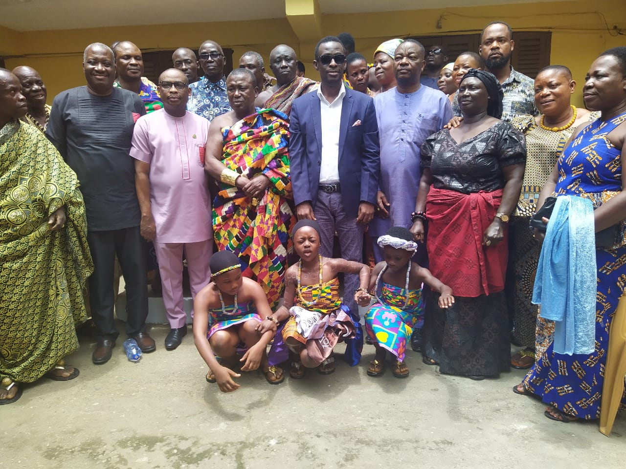
Figure 2: A picture with Traditional leaders of Lower Dixcove Traditional Council

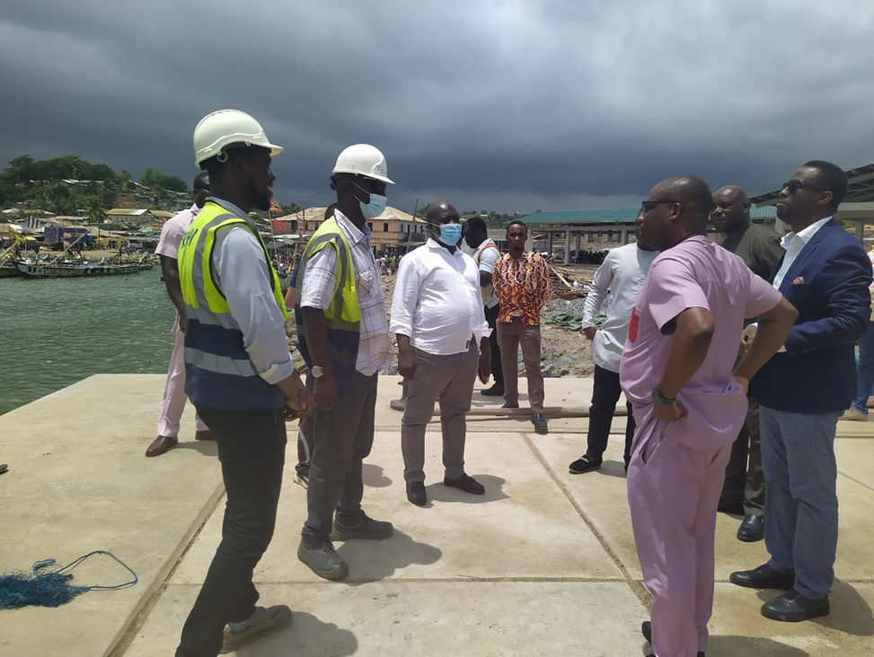
Figure 3: The Minister visited some projects within the Municipality (Sea Defense, Landing Beach)

